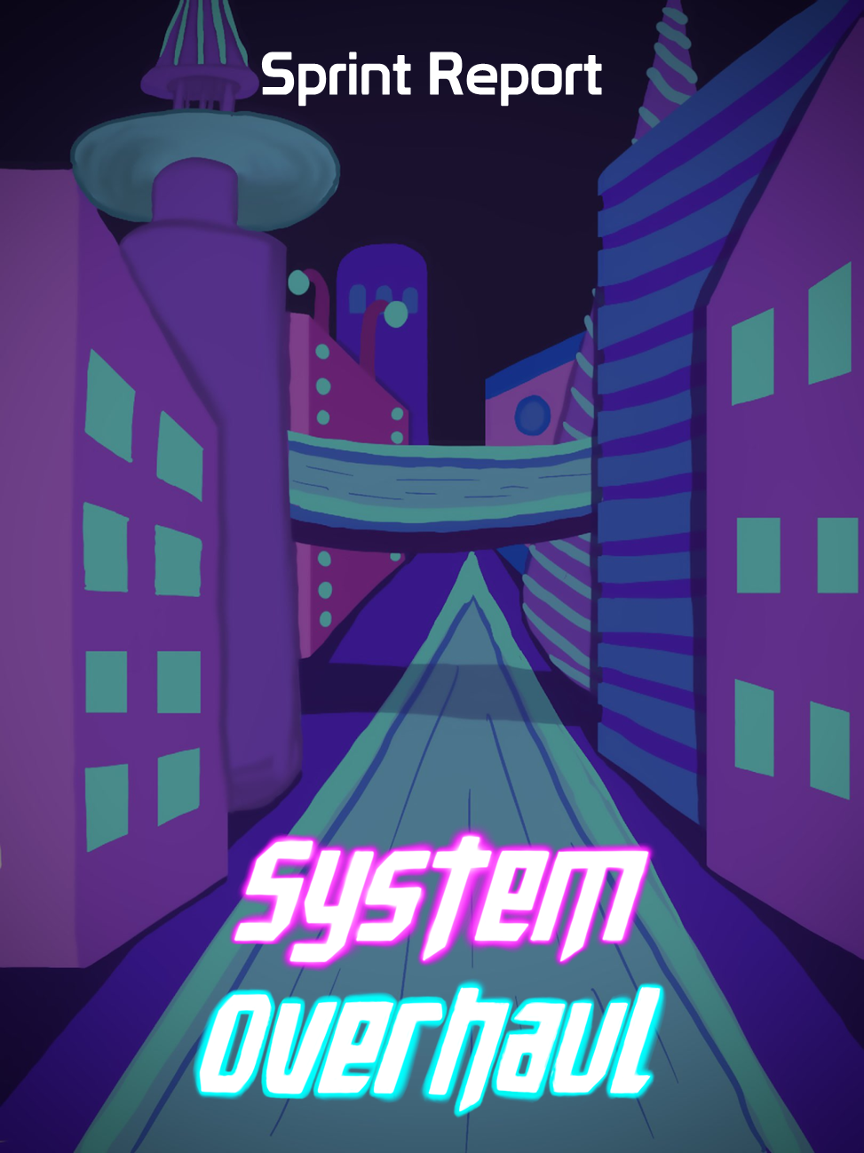





**Table of Contents**

**Previous Week** **2**

Sprint Backlog 2

Review 2

**Next Week** **3**

Sprint Backlog 3

Notes 3

# Previous Week

## Sprint Backlog

| **Tasks** | **Time Needed** | **Responsible** | **Priority** | **Stage** |
| --- | --- | --- | --- | --- |
| Player Crouching | ½ Day | Gonçalo | High | Completed |
| Text Popup for Upgrades | ½ Day | Gonçalo | High | Completed |
| Text Popup for Puzzles | ½ Day | Gonçalo | High | Completed |
| Give more feedback once ability is used | ½ Day | Gonçalo | High | Completed |
| Pause Menu | ½ Day | All | High | In Progress |
| Main Menu | ½ Day | All | High | In Progress |
| Create city | 1 Day | All | High | In Progress |

* 1. Objectives

Our objectives were completed successfully.

We had 3 tasks that were overplanned, the pause Menu, the main menu and the creation of the city.

No tasks were planned from the design part.

## Review

The tasks were done successfully and were finished in time.

# Next Week

In the “Required for CG & AI” backlog our tasks with higher priority are the following:

| **Tasks** | **Time Estimate** |
| --- | --- |
| Friendly NPCs | 3 Days |
| Player Hurt Shader | 2 Days |
| Improve Ranged Enemy | 2 Days |
| Improve Melee Enemy | 2 Days |
| Improve the NPCs | 2 Days |

In the “Coding” backlog our tasks with higher priority are the following:

| **Tasks** | **Time Estimate** |
| --- | --- |
| Fix Bugs | ½ Day |
| Pause Menu | ½ Day |
| Main Menu | ½ Day |
| Options Menu | ½ Day |
| GameOver Menu | ½ Day |

In the “3D Models & Animations” backlog the priority of the tasks didn’t change

In the “Docs” backlog the priority of the tasks didn’t change

In the “UI / 2D / Sounds” backlog the priority of the tasks didn’t change

## Sprint Backlog

| **Tasks** | **Time Estimate** | **Responsible** | **Priority** | **Stage** |
| --- | --- | --- | --- | --- |
| Create city | 1 Day | All | High | In Progress |
| Fix Bugs | 1 Day | All | High | Open |
| Friendly NPCs | 1 Day | All | High | Open |
| Instructions Doc. | ½ Day | All | High | Open |
| Delivery Report | ½ Day | All | High | Open |
| Presentation Slides | ½ Day | All | High | Open |
| Update Computer Graphics Tasks | ½ Day | All | High | Open |
| Update Artificial Intelligence Tasks | ½ Day | All | High | Open |

## Notes

Next week is the last one before the second delivery.